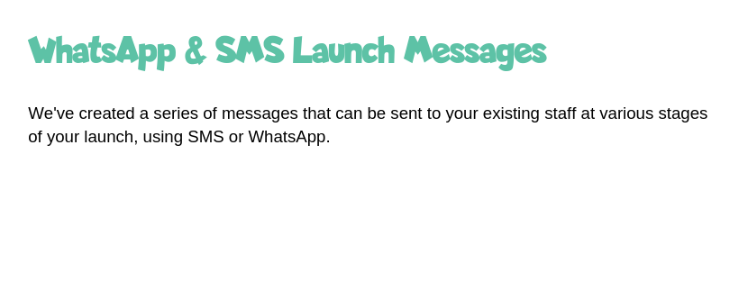

Google Play store link: <https://play.google.com/store/apps/details?id=uk.co.carefriends.app>

Apple App Store link: <https://apps.apple.com/us/app/care-friends/id1464379630?ls=1>



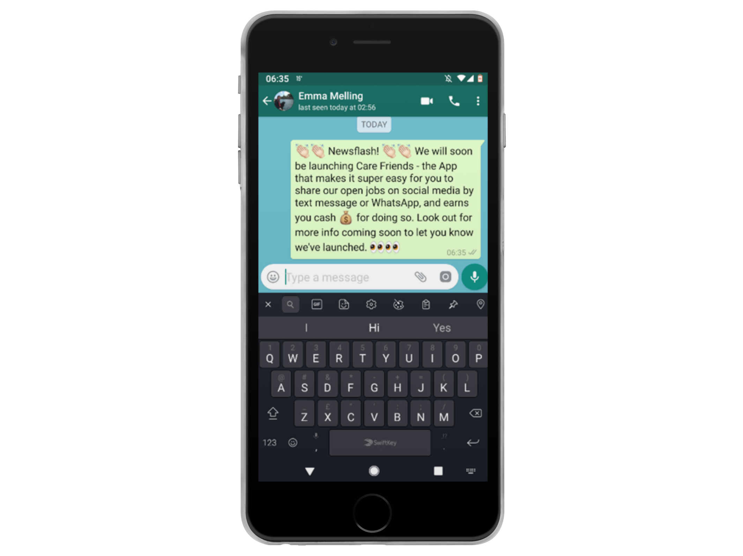

**WhatsApp One – send this one first to let your team know that Care Friends is coming!**

You can copy/paste this text if it is easier, but you will need to add emojis manually:

**Newsflash! We will soon be launching Care Friends – the App that makes it super easy for you to share our open jobs on social media by text message or WhatsApp, and earns you cash for doing so. Look out for more info coming soon to let you know we’ve launched.**



**WhatsApp Two – this message tells employees that the App is now available for them to download and should be the second one you send.**

You can copy/paste this text if it is easier, but you will need to add emojis manually:

**It’s here! We are launching Care Friends, an easy to use app which will give you the opportunity to share our jobs on social media with your friends and family. By sharing a job, you’ll earn points which you can turn into cash. What could be better? Download the app today by clicking the link below.**



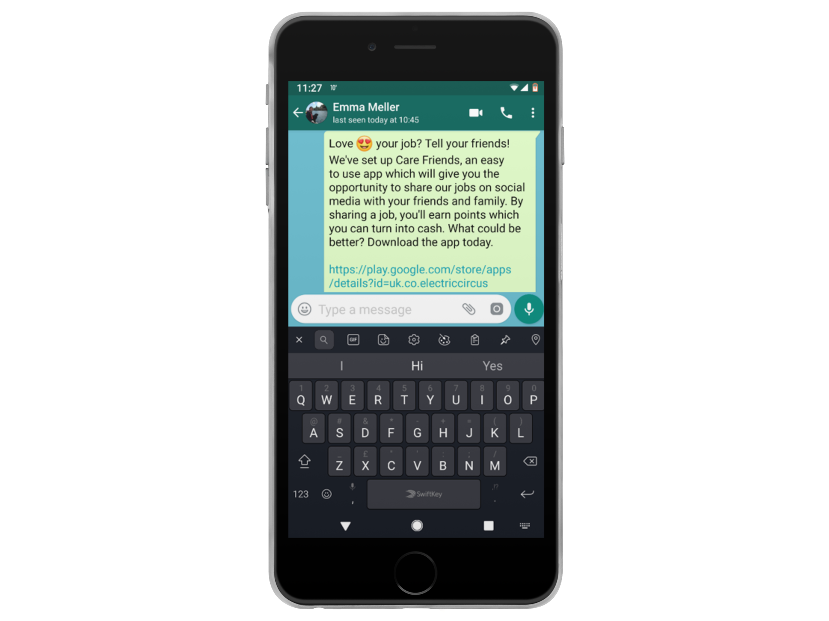

**WhatsApp Three – the first message which explains more about the App and where to go to download it.**

You can copy/paste this text if it is easier, but you will need to add emojis manually:

**Love your job? Tell your friends! We’ve set up Care Friends, an easy to use app which will give you the opportunity to share our jobs on social media with your friends and family. By sharing a job, you’ll earn points which you can turn into cash. What could be better? Download the app today.**



**WhatsApp Four – a reminder to download the app and why they should.**

You can copy/paste this text if it is easier, but you will need to add emojis manually:

**Love to care? Tell your world!  
Remember to download our new Care Friends app to be able to share jobs and earn extra cash.**



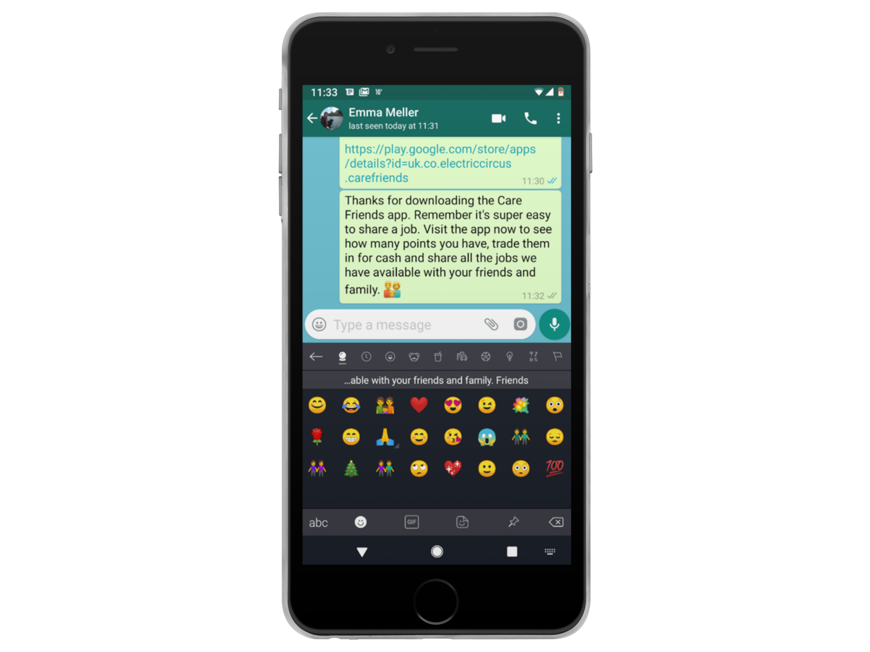

**WhatsApp Five – a reminder to check into the app and share jobs, check their points total or cash in their points.**



You can copy/paste this text if it is easier, but you will need to add emojis manually:

**Thanks for downloading the Care Friends app. Remember it’s super easy to share a job. Visit the app now to see how many points you have, trade them in for cash, and share all the jobs we have available with your friends and family.**