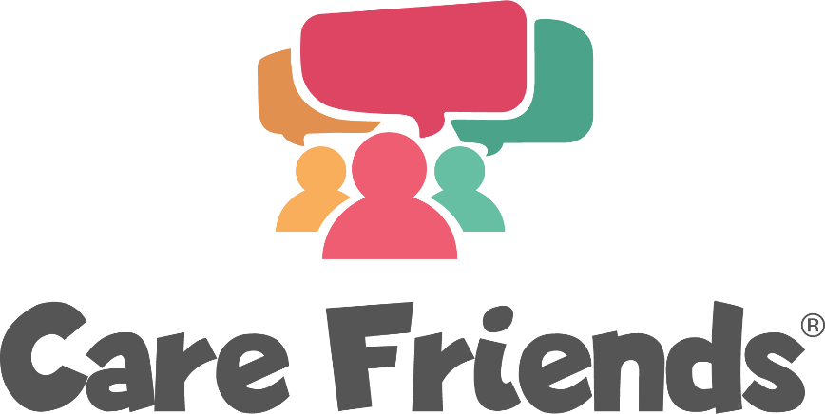

Care Friends Suggested Job Advert Wording

We suggest a gentle approach to Care Friends jobs ads in order to appeal to both passive and active job seekers.

Hi! You’re probably reading this job advert because a friend or connection of yours thinks you would make a great addition to our care team and has shared it with you.

They think you could have what it takes to be a wonderful [insert role] in our [insert organisation highlights]. Our main priority is to find people with the right values, behaviours and attitudes that match our own. It’s a great start that one of our team thought you could fit the bill!

You don’t need to have previous experience in this field, nor do you need qualifications – above all we want someone who shares our values:

[Core values]
[Core values]
[Core values]
[Core values]

If you’re interested in finding out more, just complete and send us the short Expression of Interest form below. It’s not a formal application, but it could be the first step to a rewarding role working alongside current and future friends!

Once we receive it, I will be in touch to answer questions and chat more.

Thanks!

[name of hiring manager/recruiter]

