Launch Day Facebook Post Suggested Wording
Here is a sample Facebook banner and words for you to use on your staff pages or groups on launch day.
Where possible, we recommend including the link to the app on the FB post to make it as easy as possible for your team to use the App.
You could also download our ‘Why download the Care Friends app’ video and share it with your post to make it even more engaging!

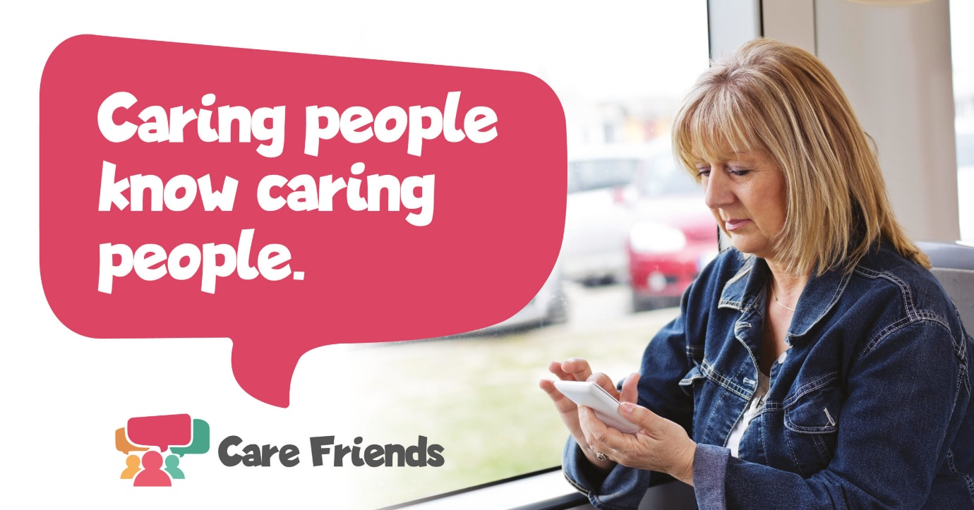
Help us recruit and we’ll help you earn! Download the Care Friends App today and start sharing jobs on social media and with your friends and family. It’s simple to use and you will start earning points as soon as you use it and points mean extra cash!
Apple App Store Link:
https://apps.apple.com/us/app/care-friends/id1464379630?ls=1
Google Play Store Link:
https://play.google.com/store/apps/details?id=uk.co.carefriends.app&hl=en_GB

