Launch Date +6 Days: Facebook Post Suggested Wording
Here is a sample Facebook banner and words for you to use on your staff pages or groups 6 days after your launch date.
Where possible, we recommend including the link to the app on the FB post to make it as easy as possible for your team to use the App.

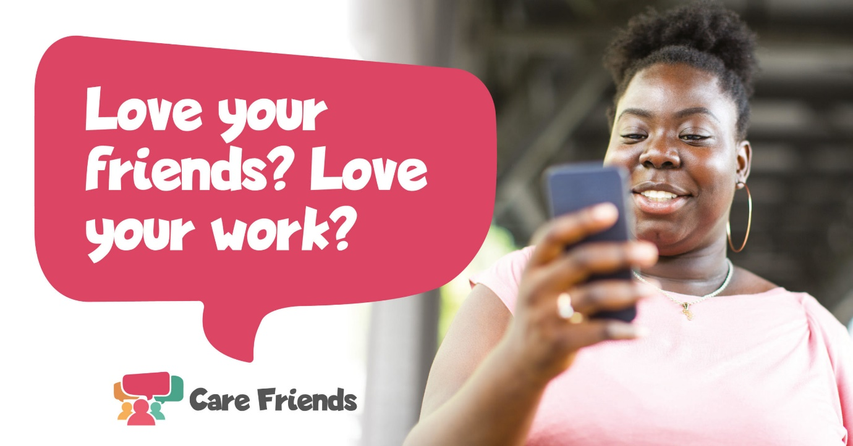
Love your friends? Love your work? Bring the two together with Care Friends, our new employee referral App. It’s super easy to use: simply share a job and you’ll earn points which you can turn into cash. Download the Care Friends App today to start referring and earning.
Apple App Store Link:
https://apps.apple.com/us/app/care-friends/id1464379630?ls=1
Google Play Store Link:
https://play.google.com/store/apps/details?id=uk.co.carefriends.app&hl=en_GB

