Launch Date +8 Days Facebook Post Suggested Wording
Here is a sample Facebook banner and words for you to use on your staff pages or groups 8 days after your launch date.
Where possible, we recommend including the link to the app on the FB post to make it as easy as possible for your team to use the App.

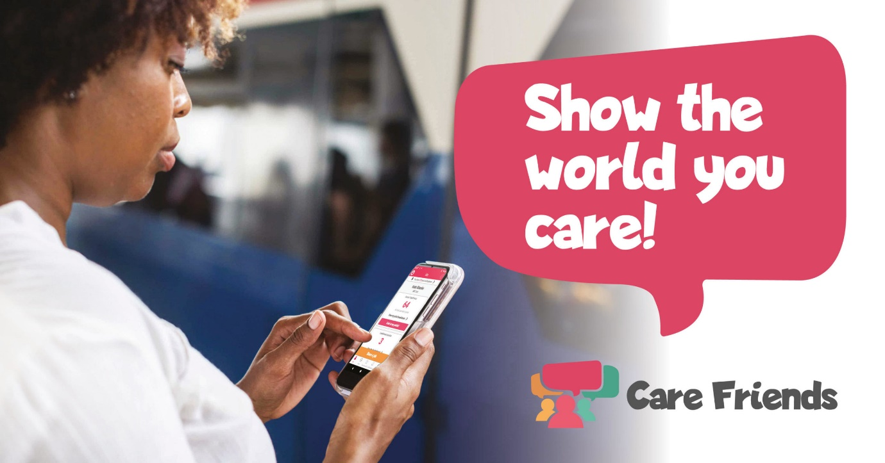
Show the world you care with Care Friends; our new App. Care Friends enables you to share our latest jobs on social media and directly with your friends through WhatsApp and SMS. It's super simple to use, easy to download and helps you earn extra cash, what could be better? Visit your app store today, search for Care Friends and download the App.
Apple App Store Link:
https://apps.apple.com/gb/app/care-friends/id1464379630
Google Play Store Link:
https://play.google.com/store/apps/details?id=uk.co.carefriends.app&hl=en_GB

