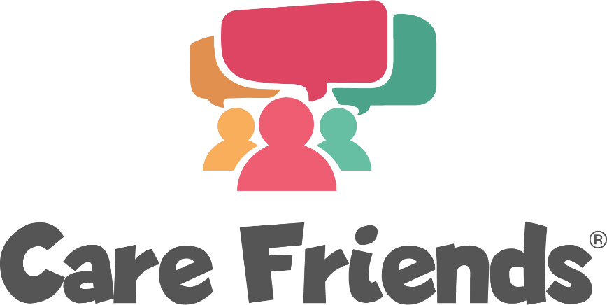

Suggested initial introduction email for admin users

We suggest sending this email to your managers, recruiters and champions as an initial introduction to Care Friends. You can then follow this up with a face-to-face meeting or video call to talk through your plans.

Title: Great news! We’re launching Care Friends!

Hello!

Employee referrals are proven to be the best way to tackle our staff shortages by helping us find quality people who stay.

So, we are going to turbocharge our referral scheme by launching Care Friends, a brand new staff referral app for social care.

It's really easy to use - check out this 4 minute video to find out more...

Care Friends explainer video (4 mins)

Thousands of care staff are already using the app and we can’t wait to get started!

We'll send more details very soon. Thank you in advance for helping us make a success of this important new resource!

