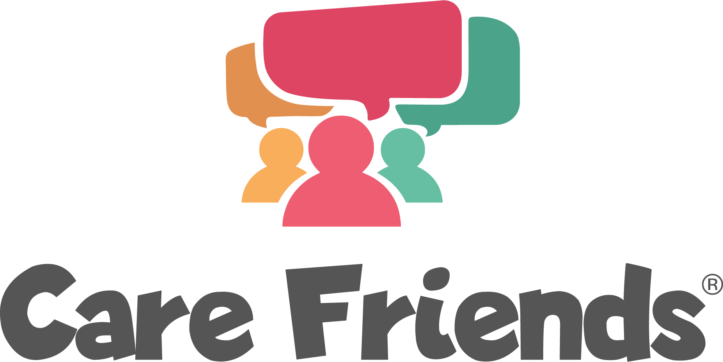

Engagement campaign ideas

Idea 1 - Social proof

Social proof is one of the most powerful ways to promote your Care Friends app. The reward will seem more "real" if staff can see their colleagues receiving rewards. Here’s an example visual and accompanying message - If you can use quotes and photos from your own team that’s even better!

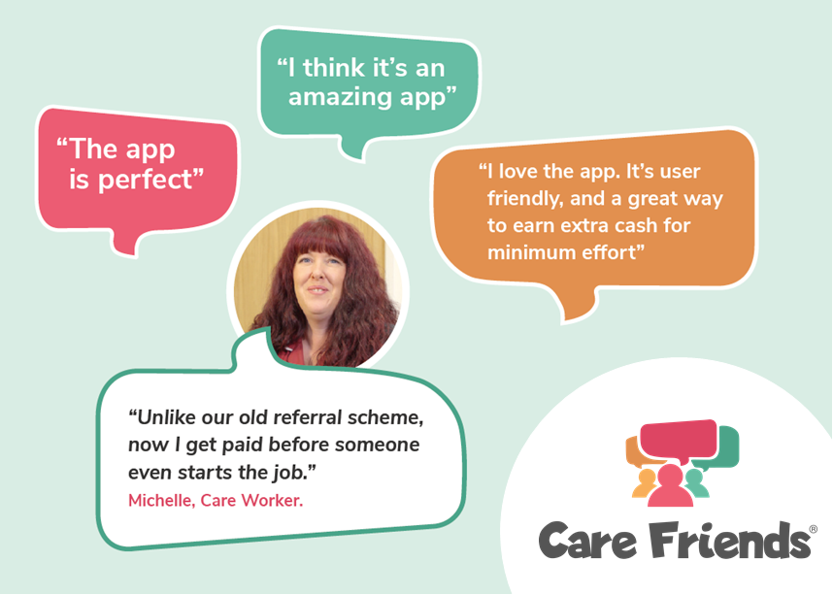
Thank you to everyone who has downloaded the Care friends app!

Join the [insert number of sign ups] members of our team who have shared a job via text, whatsapp or social media and started earning points!

Remember points = extra cash in your pocket!

Download the app for free today by clicking the link below and follow the instructions to register

Go to the Google play store
https://play.google.com/store/apps/details?id=uk.co.carefriends.app&hl=en_GB

Go to the apple app store
https://apps.apple.com/us/app/care-friends/id1464379630?ls=1

Idea 2 - Remind everyone how much they can earn!

[insert points values chart - download the chart template here]

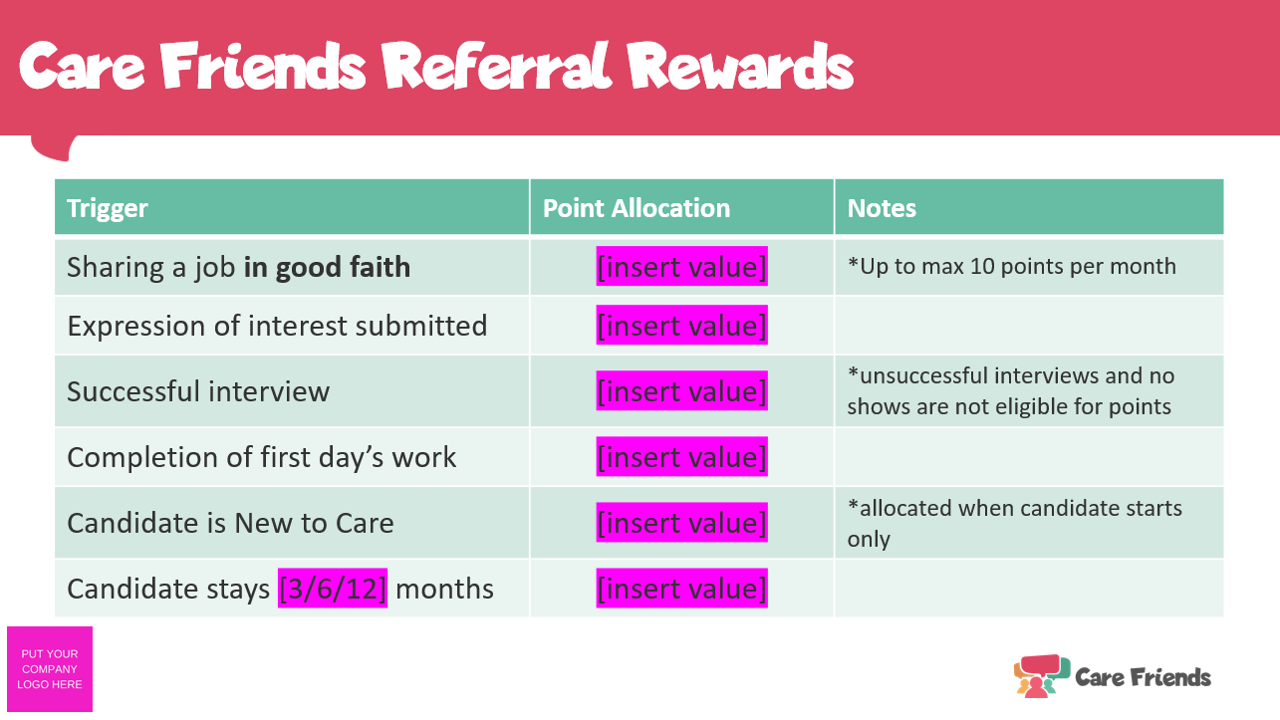

Thanks to everyone who has downloaded the Care Friends app so far!

When you refer a friend using the Care Friends app you receive rewards for each step of the hiring process, not just hires!

Visit the app now to see how many points you have and share the jobs we have available with your friends and family.

Not signed up yet? Download the app for free today by clicking the link below and follow the instructions to register

Go to the Google play store
https://play.google.com/store/apps/details?id=uk.co.carefriends.app&hl=en_GB

Go to the apple app store
https://apps.apple.com/us/app/care-friends/id1464379630?ls=1

Idea 3 - Celebrate your successful referrers and their friends who have started work with you.

Celebrating successes is a fantastic way to build engagement. The scheme will seem more "real" if staff can see their colleagues receiving rewards. It would be great to get quotes from the referrer and new starter to share via your usual comms method.

You can encourage effective quotes by asking the following questions:
- For your referrer - "What's the best thing about referring a friend via the Care Friends app?"
- For your new starter - "What excited you most about being referred by a friend?"
Always include links to download for those who haven’t signed up yet
Go to the Google play store
https://play.google.com/store/apps/details?id=uk.co.carefriends.app&hl=en_GB

Go to the apple app store
https://apps.apple.com/us/app/care-friends/id1464379630?ls=1

[Insert referrer name with permission] from our team has earned an extra [insert value] for referring her friend [insert new starter name with permission] to join us!
Every time you refer someone that successfully starts a job with us you earn [insert value]! If that friend is also new to care you earn a [insert value] bonus!
If you haven't signed up to the Care Friends app yet, do it today and start earning extra cash too!
Follow the link below to download the app for free and follow the simple instructions to register - it only takes 60 seconds to sign up and start earning rewards just like [insert name] did!
Google play store
https://play.google.com/store/apps/details?id=uk.co.carefriends.app&hl=en_GB
Apple app store
https://apps.apple.com/us/app/care-friends/id1464379630?ls=1

Idea 4 - Celebrate your organisation’s success with these quick and easy message templates

Template 1

So far our team has earned a total of [insert value] in points via the Care Friends app - that's AMAZING! To sign up and start earning too, download the Care Friends app for free and follow the instructions to register.
Google play store
https://play.google.com/store/apps/details?id=uk.co.carefriends.app&hl=en_GB
Apple app store
https://apps.apple.com/us/app/care-friends/id1464379630?ls=1

Template 2

Every time you refer someone that successfully starts a job with us you earn [insert value]! And in just [insert value] months, thanks to all of you, we've got [insert value] new employees. If you haven't signed up to the Care Friends app yet, do it today and start earning extra cash too!
Google play store https://play.google.com/store/apps/details?id=uk.co.carefriends.app&hl=en_GB
Apple app store
https://apps.apple.com/us/app/care-friends/id1464379630?ls=1

