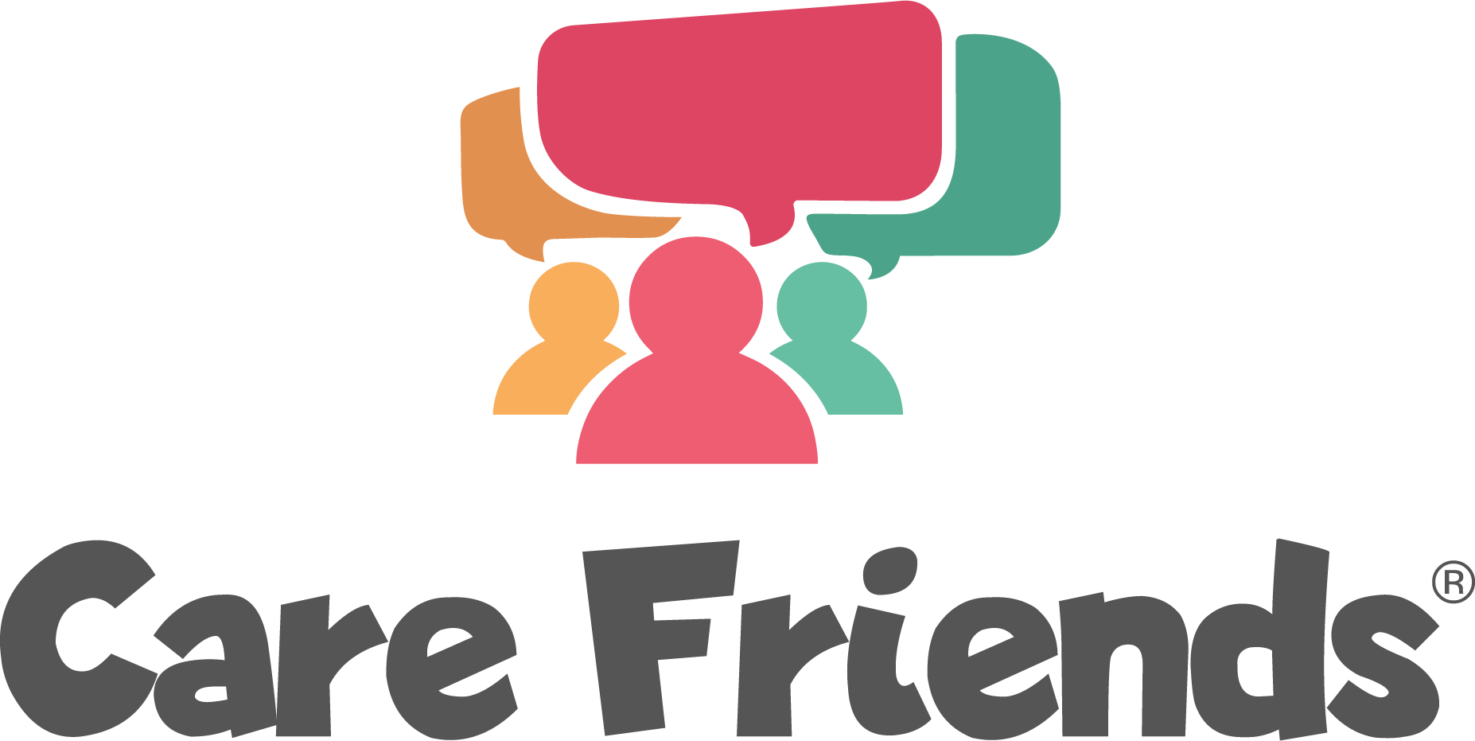

Launch email templates

Email 1: Send 1 week before launch

Care Friends is coming…

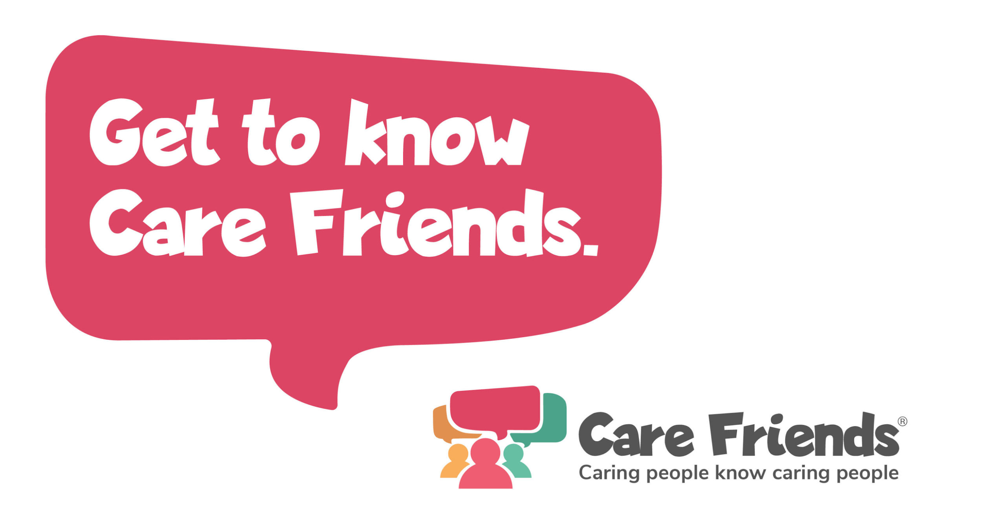
Hi everyone!

Do you know someone who would make a great addition to our team?
Well, we want to reward you for helping us find even more great people like you!

I am delighted to announce that on [insert date] we are launching Care Friends, an employee referral app especially for care staff.

By referring your friends and family, you will receive points on your app, and these points will be converted to cash!

Watch this video to find out more and look out for more info coming soon!

Get to know Care Friends

Email 2: Send on Launch day

Care Friends is here!

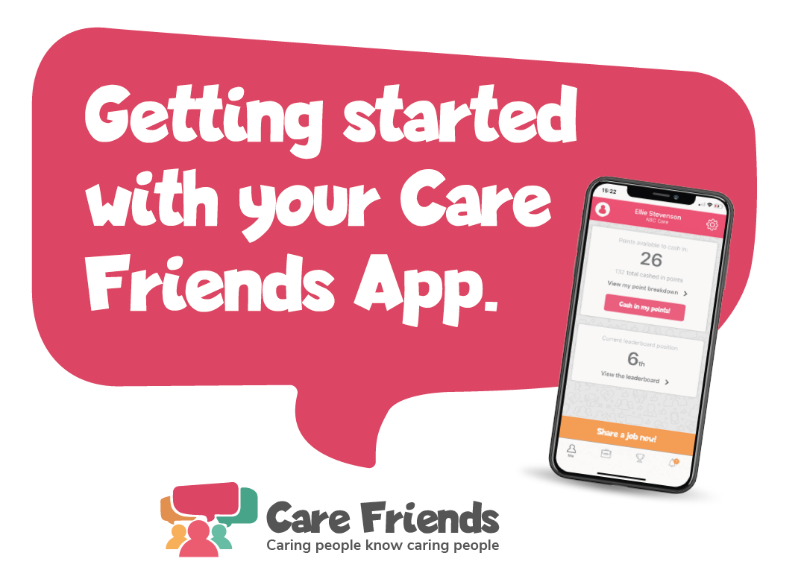

It’s here! We are launching Care Friends, an easy to use app which will give you the opportunity to share our jobs via text, Whatsapp or social media with your friends
and family and get rewarded for doing so! By sharing a job, you’ll earn points which you can turn into cash. What could be better?

Check out the attached how-to guide to get started and download the app for free today by clicking the link below

Go to the Google play store
https://play.google.com/store/apps/details?id=uk.co.carefriends.app&hl=en_GB

Go to the apple app store
https://apps.apple.com/us/app/care-friends/id1464379630?ls=1

[insert launch incentive]

Email 3: Send 2 days after launch

Join the Care Friends app today!

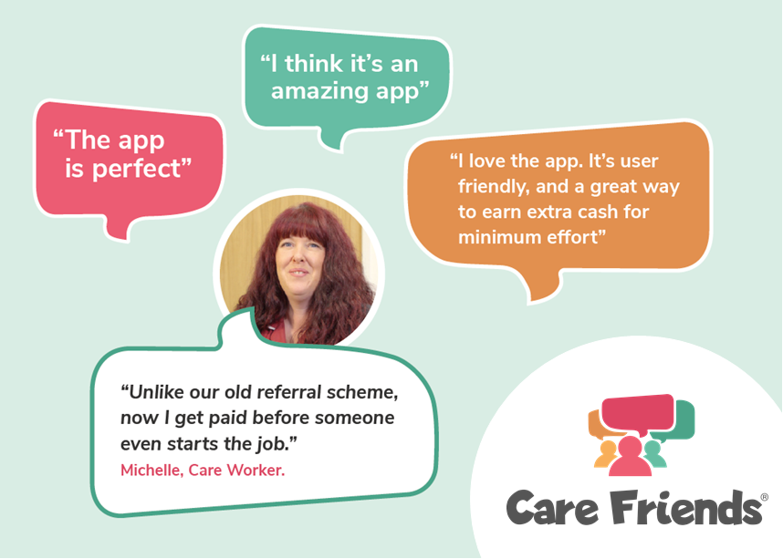

Hi everyone!

Thank you to everyone who has downloaded the Care friends app!

Join the [insert number of sign ups] members of our team who have shared a job via text, whatsapp or social media and started earning points!

Remember points = extra cash in your pocket!

Download the app for free today by clicking the link below and follow the instructions to register

Go to the Google play store
https://play.google.com/store/apps/details?id=uk.co.carefriends.app&hl=en_GB

Go to the apple app store
https://apps.apple.com/us/app/care-friends/id1464379630?ls=1

[insert launch incentive reminder]
Email 4: Send 4 days after launch

Earn extra cash with the Care Friends app!

[insert points values chart - find a template for this here you can find your organisation’s points values in the ‘Referral points’ tab in the ‘Settings’ section of your portal.]
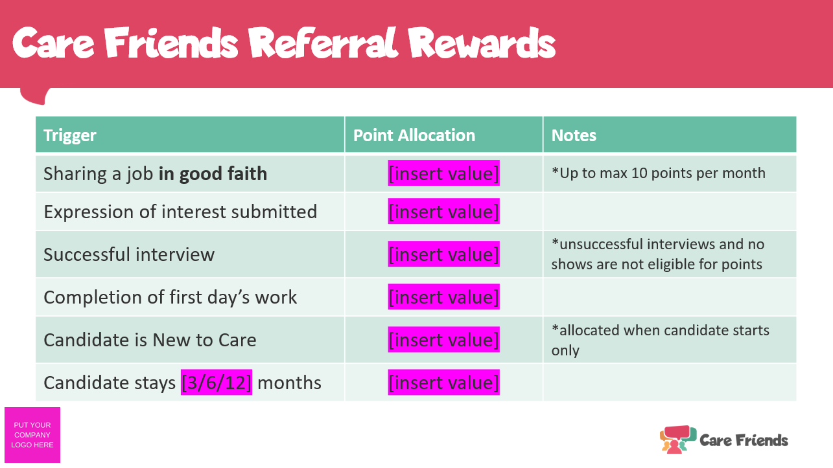

Thanks to everyone who has downloaded the Care Friends app so far!

When you refer a friend using the Care Friends app you receive rewards for each step of the hiring process, not just hires!

Visit the app now to see how many points you have and share the jobs we have available with your friends and family.

Not signed up yet? Download the app for free today by clicking the link below and follow the instructions to register

Go to the Google play store
https://play.google.com/store/apps/details?id=uk.co.carefriends.app&hl=en_GB

Go to the apple app store
https://apps.apple.com/us/app/care-friends/id1464379630?ls=1

[insert launch incentive reminder]
Email 5: Send 7 days after launch

Care Friends Week 1

Hi everyone,

Thank you for your support for Care friends!

In just one week, thanks to all of you, we’ve had [insert expressions of interest + other highlights] - that’s amazing!

If you haven't signed up to the Care Friends app yet, do it today and start earning extra cash for referring you friends too!

Here’s a quick video to show you how easy it is to get started…

https://www.loom.com/share/f38a1c5276c04804b19b1d46360481c5

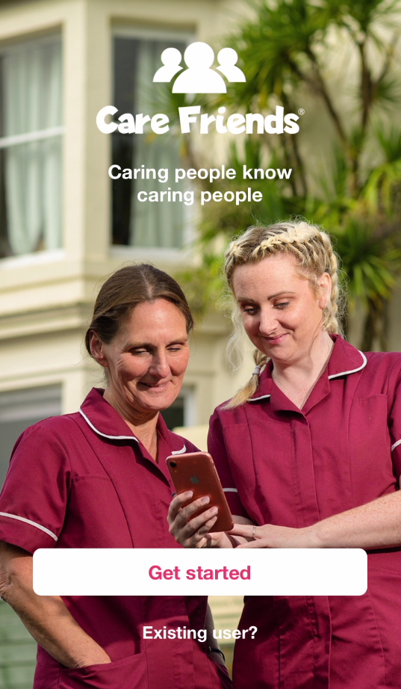

Email 6: Send 9 days after launch

[Insert welcome bonus/prize draw as the title]

Hi everyone!

Remember to download the Care Friends app to [insert launch incentive details]

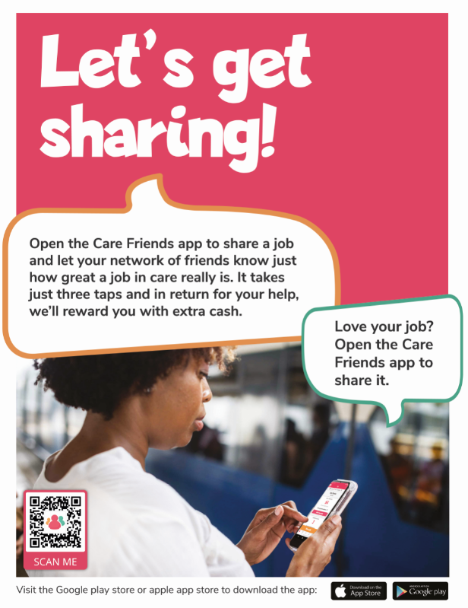

Our [insert launch incentive details] finishes on [insert sign up incentive deadline], so don’t delay! Head to the Google play store or the apple app store and download the app for free!

Go to the Google play store
https://play.google.com/store/apps/details?id=uk.co.carefriends.app&hl=en_GB

Go to the apple app store
https://apps.apple.com/us/app/care-friends/id1464379630?ls=1

Email 7: Send on launch incentive deadline as a push notification

Click here to learn how to send a Care Friends push notification

If you have given a welcome bonus to all users
Thank you for signing up to Care Friends!
We really appreciate you getting involved and referring your friends and family to join us. Happy sharing!

If you are offering a prize draw incentive
For the winners:
Congratulations! You’re a winner!
Thank you so much for signing up to the Care Friends app! We’re excited to announce that you have won 50 bonus points in our prize draw! Head into your app to cash them in or save them up for something special!

For all app users:
Thank you for signing up to Care Friends!
The prizes have been drawn and 10 lucky winners have received 50 bonus points! We really appreciate you getting involved and referring your friends and family to join us. Happy sharing!

