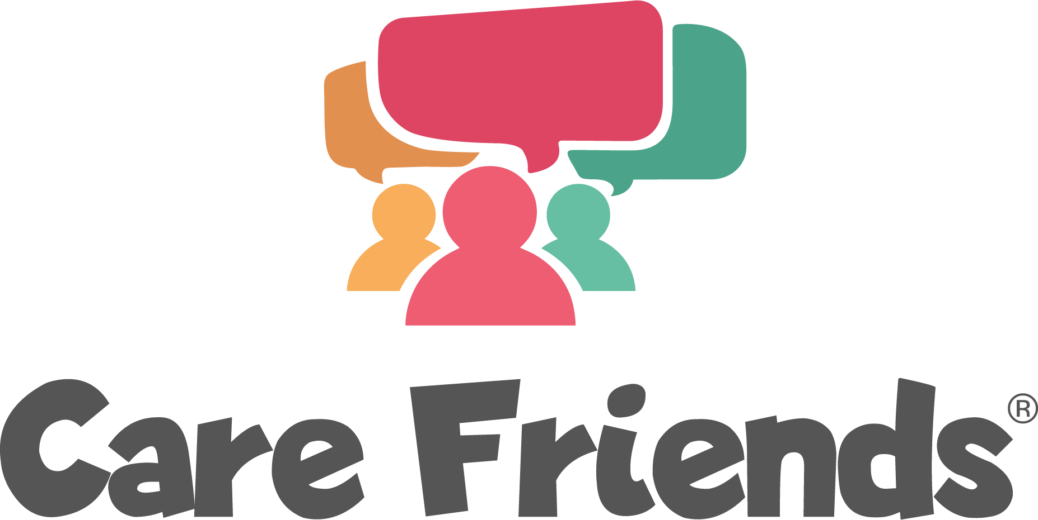

Post-Launch Email Templates

Email 3: Send 2 days after launch

Join the Care Friends app today!

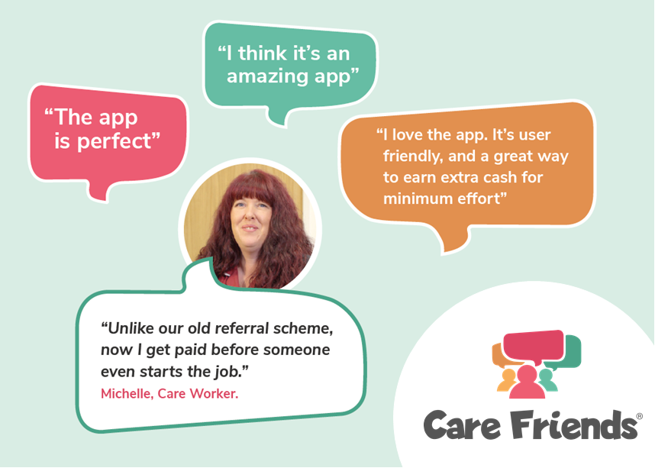

Hi everyone!

Thank you to everyone who has downloaded the Care friends app!

Join the [insert number of sign ups] members of our team who have shared a job via text, whatsapp or social media and started earning points!

Remember points = extra cash in your pocket!

Download the app for free today by clicking the link below and follow the instructions to register

Go to the Google play store
https://play.google.com/store/apps/details?id=uk.co.carefriends.app&hl=en_GB

Go to the apple app store
https://apps.apple.com/us/app/care-friends/id1464379630?ls=1

[insert launch incentive reminder]
Email 4: Send 4 days after launch

Earn extra cash with the Care Friends app!

[insert points values chart - find a template for this here you can find your organisation’s points values in the ‘Referral points’ tab in the ‘Settings’ section of your portal.]
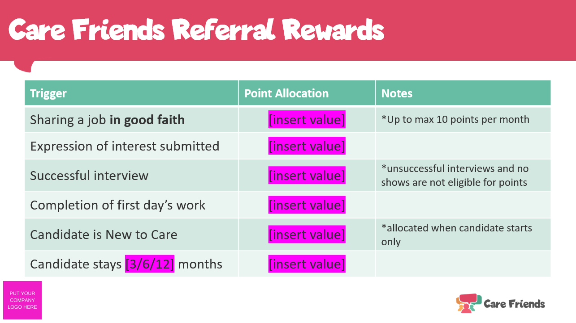

Thanks to everyone who has downloaded the Care Friends app so far!

When you refer a friend using the Care Friends app you receive rewards for each step of the hiring process, not just hires!

Visit the app now to see how many points you have and share the jobs we have available with your friends and family.

Not signed up yet? Download the app for free today by clicking the link below and follow the instructions to register

Go to the Google play store
https://play.google.com/store/apps/details?id=uk.co.carefriends.app&hl=en_GB

Go to the apple app store
https://apps.apple.com/us/app/care-friends/id1464379630?ls=1

[insert launch incentive reminder]
Email 5: Send 7 days after launch

Care Friends Week 1

Hi everyone,

Thank you for your support for Care friends!

In just one week, thanks to all of you, we’ve had [insert expressions of interest + other highlights] - that’s amazing!

If you haven't signed up to the Care Friends app yet, do it today and start earning extra cash for referring you friends too!

Here’s a quick video to show you how easy it is to get started…

https://www.loom.com/share/f38a1c5276c04804b19b1d46360481c5

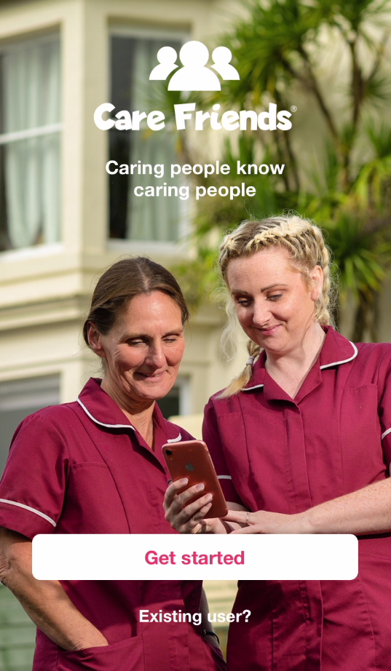

Email 6: Send 9 days after launch

[Insert welcome bonus/prize draw as the title]

Hi everyone!

Remember to download the Care Friends app to [insert launch incentive details]

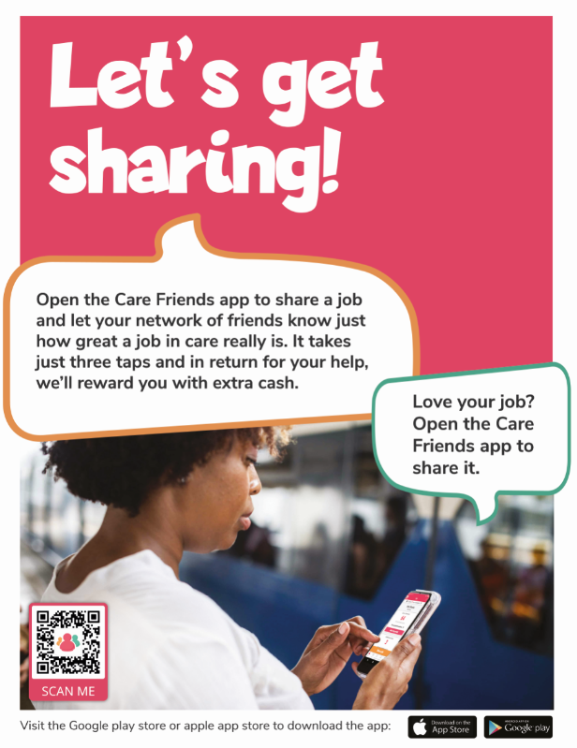

Our [insert launch incentive details] finishes on [insert sign up incentive deadline], so don’t delay! Head to the Google play store or the apple app store and download the app for free!

Go to the Google play store
https://play.google.com/store/apps/details?id=uk.co.carefriends.app&hl=en_GB

Go to the apple app store
https://apps.apple.com/us/app/care-friends/id1464379630?ls=1

