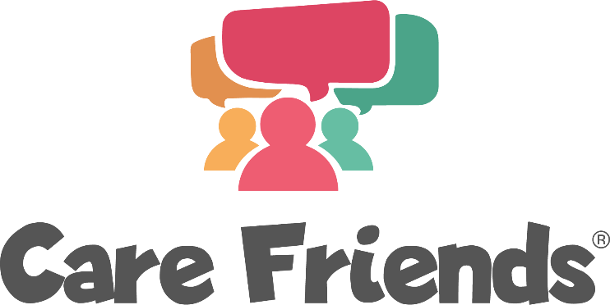
Post-Launch Team Facebook Posts
Use this series of Facebook posts to keep up momentum following launch day. Follow the link below to download the jpeg image files that accompany these posts.
Download the jpeg image files here
Facebook Post 3 – post 2 days after launch day

How many friends do you have on Facebook? Plenty, for sure! Download the Care Friends App and start sharing jobs on Facebook. As soon as you do, you can start earning points which you can then turn into cash!
Need help registering? Contact our Care Friends Champion [insert name] who will be happy to help.
Apple App Store Link:
https://apps.apple.com/us/app/care-friends/id1464379630?ls=1
Google Play Store Link:
https://play.google.com/store/apps/details?id=uk.co.carefriends.app&hl=en_GB

Facebook Post 4 – post 4 days after launch day

Love to care? Tell your world! Care Friends is a new App that will help you refer friends to work alongside you. Share a post on Facebook, WhatsApp or via SMS and earn points which you can turn into cash. It's simple to use and easy to register. Just visit your App store, search for Care Friends and you'll be guided through the rest.
Need help registering? Contact our Care Friends Champion [insert name] who will be happy to help.
Apple App Store Link:
https://apps.apple.com/us/app/care-friends/id1464379630?ls=1
Google Play Store Link:
https://play.google.com/store/apps/details?id=uk.co.carefriends.app&hl=en_GB

Facebook post 5 – post 6 days after launch day
Here is a sample Facebook banner and words for you to use on your staff pages or groups 6 days after your launch date.
Where possible, we recommend including the link to the app on the FB post to make it as easy as possible for your team to use the App.

Love your friends? Love your work? Bring the two together with Care Friends, our new employee referral App. It’s super easy to use: simply share a job and you’ll earn points which you can turn into cash. Download the Care Friends App today to start referring and earning.
Need help registering? Contact our Care Friends Champion [insert name] who will be happy to help.
Apple App Store Link:
https://apps.apple.com/us/app/care-friends/id1464379630?ls=1
Google Play Store Link:
https://play.google.com/store/apps/details?id=uk.co.carefriends.app&hl=en_GB

Facebook post 6 – post 8 days after launch day

Show the world you care with Care Friends; our new App. Care Friends enables you to share our latest jobs on social media and directly with your friends through WhatsApp and SMS. It's super simple to use, easy to download and helps you earn extra cash, what could be better? Visit your app store today, search for Care Friends and download the App.
Need help registering? Contact our Care Friends Champion [insert name] who will be happy to help.
Apple App Store Link:
https://apps.apple.com/gb/app/care-friends/id1464379630
Google Play Store Link:
https://play.google.com/store/apps/details?id=uk.co.carefriends.app&hl=en_GB

