

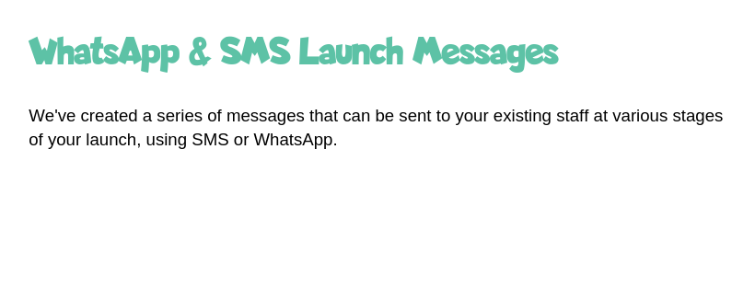

**We’ve created a series of messages that can be sent to your existing staff at various stages using SMS or Whatsapp.**

**Remember to include your launch incentive details!**

**Add emojis to your messages to make them personal and fun!**

**WhatsApp Three – the first message which explains more about the App and where to go to download it.**

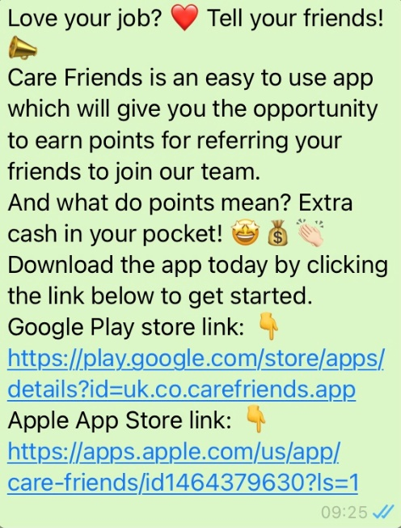

**Love your job? Tell your friends! Care Friends is an easy-to-use app which gives you the opportunity to earn points for referring your friends to join our team.**

**And what do points mean? Extra cash in your pocket!**

**Download the app today by clicking the link below to get started.**

**Google Play store link:** [**https://play.google.com/store/apps/details?id=uk.co.carefriends.app**](https://play.google.com/store/apps/details?id=uk.co.carefriends.app)

**Apple App Store link:** [**https://apps.apple.com/us/app/care-friends/id1464379630?ls=1**](https://apps.apple.com/us/app/care-friends/id1464379630?ls=1)



**WhatsApp Four – a reminder to download the app and why they should.**

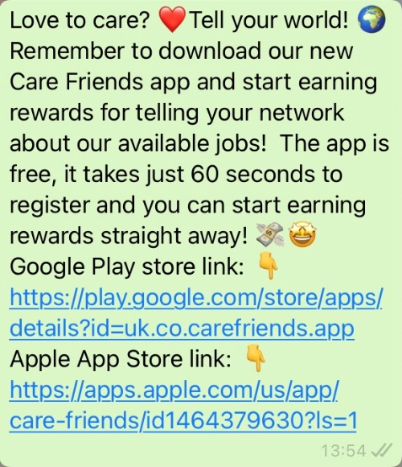

**Love to care? Tell your world!  
Remember to download our new Care Friends app to start earning rewards for telling your network about our available jobs!**

**The app is free, it takes just 60 seconds to register and you can start earning rewards straight away!**

**Google Play store link:** [**https://play.google.com/store/apps/details?id=uk.co.carefriends.app**](https://play.google.com/store/apps/details?id=uk.co.carefriends.app)

**Apple App Store link:** [**https://apps.apple.com/us/app/care-friends/id1464379630?ls=1**](https://apps.apple.com/us/app/care-friends/id1464379630?ls=1)



**WhatsApp Five – a reminder to check into the app and share jobs, check their points total or cash in their points.**

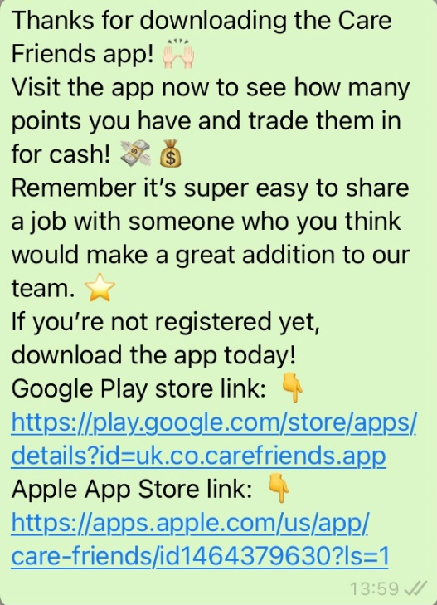

**Thanks for downloading the Care Friends app. Visit the app now to see how many points you have and trade them in for cash. Remember it’s super easy to share a job with someone who you think would make a great addition to our team.**

**If you’re not registered yet, download the app today!**

**Google Play store link:** [**https://play.google.com/store/apps/details?id=uk.co.carefriends.app**](https://play.google.com/store/apps/details?id=uk.co.carefriends.app)

**Apple App Store link:** [**https://apps.apple.com/us/app/care-friends/id1464379630?ls=1**](https://apps.apple.com/us/app/care-friends/id1464379630?ls=1)

