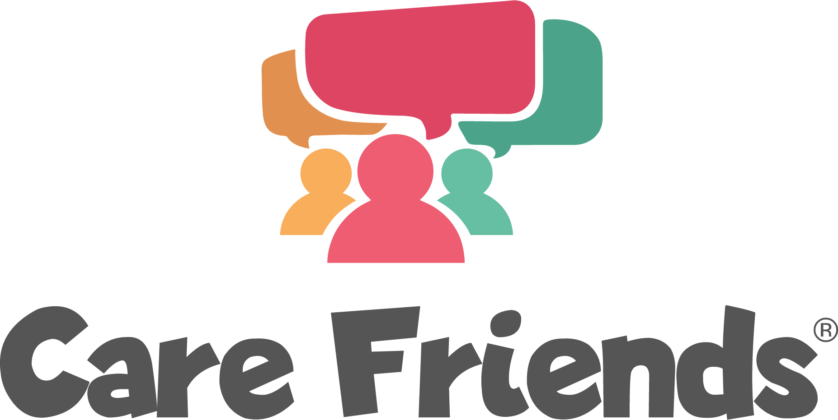

Send an app push notification to celebrate the success of your launch phase

- Select the template below that applies to your chosen launch incentive
- Complete the highlighted section with your organisation details
- Click the link at the bottom of the page to learn how to send a notification from your Care Friends portal.

If you have given a welcome bonus to all users
Thank you for signing up to Care Friends!
We really appreciate you getting involved and referring your friends and family to join us. Happy sharing!

If you are offering a prize draw incentive
For the winners:
Congratulations! You’re a winner!
Thank you so much for signing up to the Care Friends app! We’re excited to announce that you have won [insert value] bonus points in our prize draw! Head into your app to cash them in or save them up for something special!

For all app users:
Thank you for signing up to Care Friends!
The prizes have been drawn and [insert value] lucky winners have received [insert value] bonus points! We really appreciate you getting involved and referring your friends and family to join us. Happy sharing!

How to send a push notification

