Pre-Launch Facebook Post Suggested Wording
Here is a sample Facebook banner and words for you to use on your staff pages or groups a week before launch.

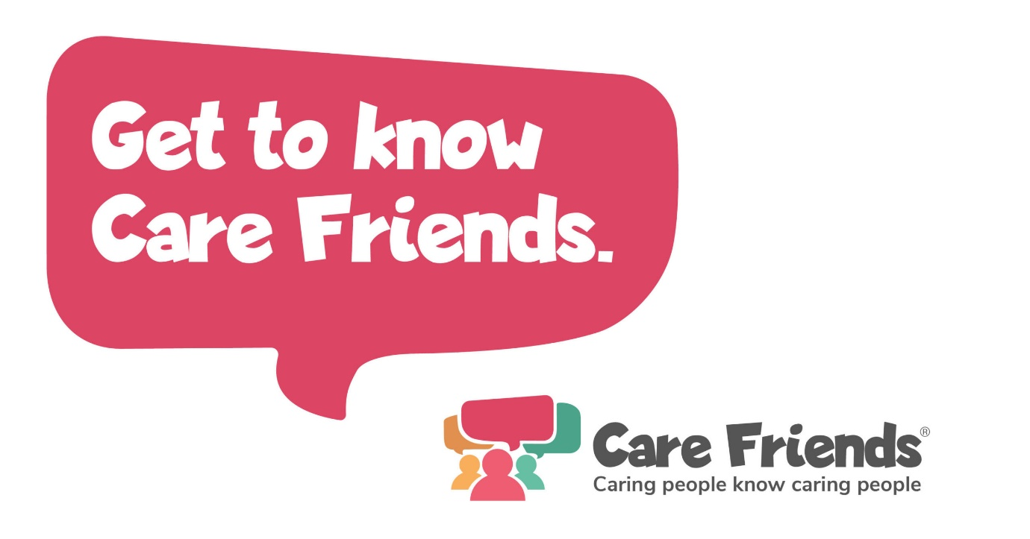
We'll shortly be launching an App to help you earn extra cash! Care Friends is a new scheme which will make referring a friend quick and easy! By sharing jobs via social media, WhatsApp and text, you’ll earn points and you can turn those points into cash! You’ll also be able to earn bonus points for going the extra mile. We'll be in touch soon with more information!

