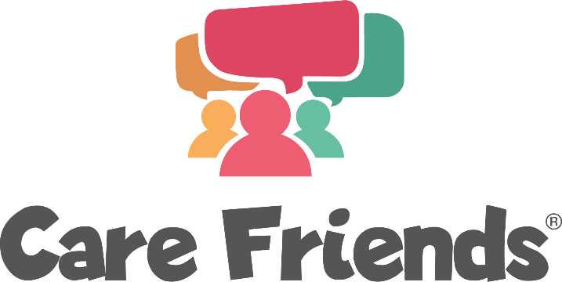

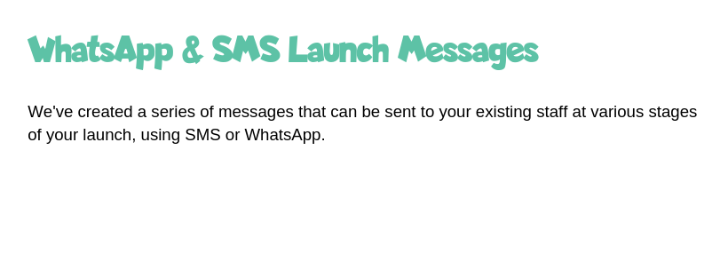

**We’ve created a series of messages that can be sent to your existing staff at various stages using SMS or Whatsapp.**

**Add emojis to your messages to make them personal and fun!**

**Remember to include your launch incentive details!**

**WhatsApp Two – this message tells employees that the App is now available for them to download and should be the second one you send.**

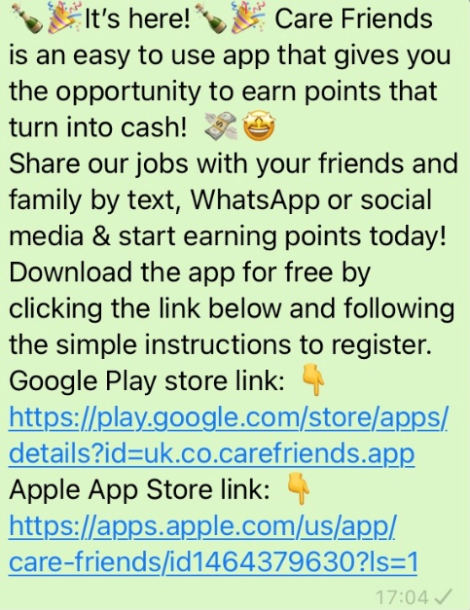

**It’s here! We are launching Care Friends, an easy to use app that gives you the opportunity to earn points that turn into cash!**

**Share our jobs on social media with your friends and family and start earning points today!**

**Download the app for free by clicking the link below and following the simple instructions to register.**

**Google Play store link:** [**https://play.google.com/store/apps/details?id=uk.co.carefriends.app**](https://play.google.com/store/apps/details?id=uk.co.carefriends.app)

**Apple App Store link:** [**https://apps.apple.com/us/app/care-friends/id1464379630?ls=1**](https://apps.apple.com/us/app/care-friends/id1464379630?ls=1)