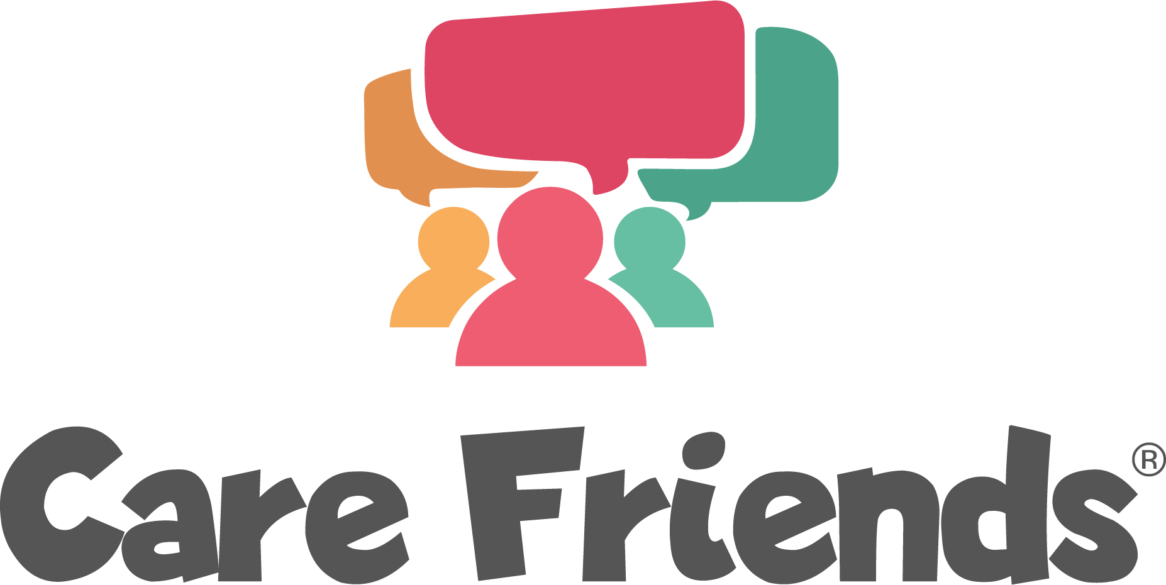

Share successes via your usual communication methods and as an app push notification

- Select the template below that applies to your success

- Complete the highlighted section(s) with your organisation details
TIP: You can find your referral rewards in your Care Friends portal. Head to Settings in the left-hand menu, then Referral Points in the top tabs

- Click here to learn how to send a notification from your Care Friends portal. Remember, only those who are registered for the app will see push notifications, so it is a good idea to share successes via your usual communication methods too.

Launch incentives
If you have given a welcome bonus to all users
Thank you for signing up to Care Friends!
We really appreciate you getting involved and referring your friends and family to join us. Happy sharing!

If you are offering a prize draw incentive
For the winners:
Congratulations! You’re a winner!
Thank you so much for signing up to the Care Friends app! We’re excited to announce that you have won [insert value] bonus points in our prize draw! Head into your app to cash them in or save them up for something special!

For everyone:
Thank you for signing up to Care Friends!
The prizes have been drawn and [insert value] lucky winners have received [insert value] bonus points! We really appreciate you getting involved and referring your friends and family to join us. Happy sharing!

Celebrating successes

Great sharing efforts
Join the [insert number] members of our team who have shared a job via text, whatsapp or social media and earned points.
Remember points = extra pounds in your pocket!

Successful expressions of interest
Join the [insert number] members of our team who have earned points this month for referring friends to join our team!
Remember points = extra pounds in your pocket!

Celebrate your leaderboard
Join the [insert number] members of our team who have earned X number of points
Remember points = extra pounds in your pocket!

Hiring success
Newsflash!!
Thank you to [Insert referrer name] for referring your friend to join our team!
As a token of our appreciation, [insert referrer name] has received [insert total referral points] in their Care Friends app! 🤩
We'd love to hear from anyone who you think would make a great addition to the team. Simply share a job with them via the Care Friends app and you will automatically get points which you can exchange for cash!

Retention success
Newsflash!!
Thank you everyone for sharing our jobs with your friends and family.
We are excited to announce that [insert referrer name] has just received the jackpot! Their friend has stayed with us for [insert number] months so they have now received the full [insert value] points! Refer a friend today - the longer they stay the more points you earn!

Reminders

Time to share a job!
A few taps in Care Friends today could earn you up to [insert total referral reward]! What are you waiting for?! Share a job today!

Love to care? Tell your world!
Let your network of friends know just how great working with insert organisation name really is! It takes just 3 taps and in return for your help we'll reward you with extra cash.

Let's get sharing!
Share a job on social media and get rewarded with points that you turn into cash!

