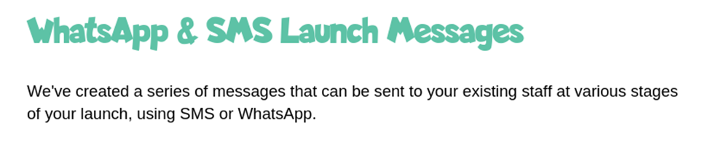

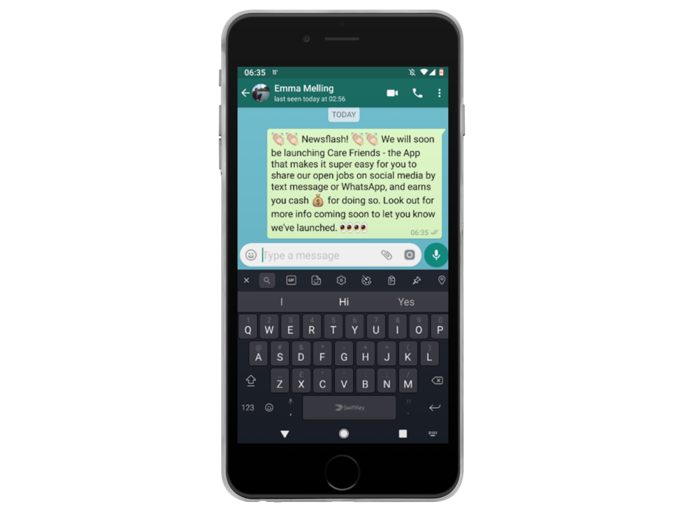

**SMS/WhatsApp One – send this a week before launch to let your team know that Care Friends is coming!**

**Newsflash! We will soon be launching Care Friends – the App that makes it super easy for you to earn extra cash for sharing our open jobs on social media, by text message or WhatsApp. Look out for more info coming soon!**

**Use emojis to make the message as personal and fun as possible!**

