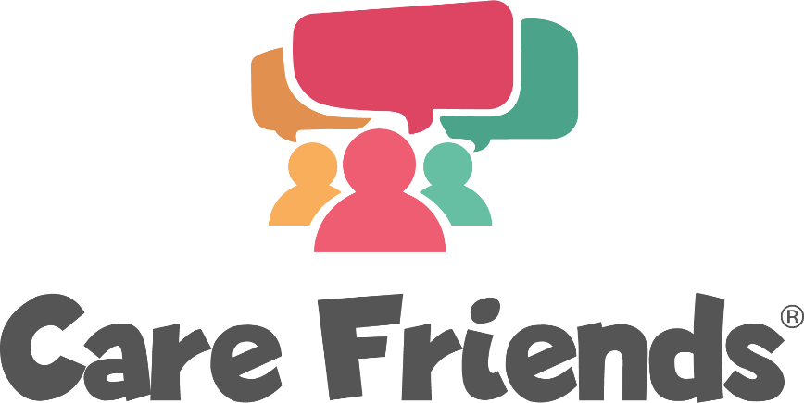

Suggested initial introduction email for admin users

We suggest sending this email to colleagues who you would like to be admin users as an initial introduction to Care Friends. You could then follow this up with a face-to-face meeting or video call to talk through your plans.

Great news! We’re going to find more high-quality staff who stay longer!

Hello!

Employee referrals are proven to be the best way to tackle our staff shortages by helping us find quality people who stay.

So, we are going to turbocharge our employee referral scheme by launching Care Friends, a brand-new staff referral app for social care.

Check out this 4 minute video to find out more...

Care Friends explainer video (4 mins)

Thousands of care staff are already using the app and we can’t wait to get started!

Please follow the link below to book a training session or watch a recording

https://calendly.com/nicolacarefriends/care-friends-admin-user-training

Thank you in advance for helping us make a success of this important new resource!

