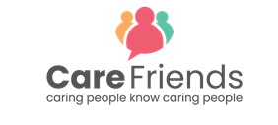

Teaser Facebook Post
Simply copy and paste the template into your Facebook post.
You can download the jpeg version of the image to go with the post here
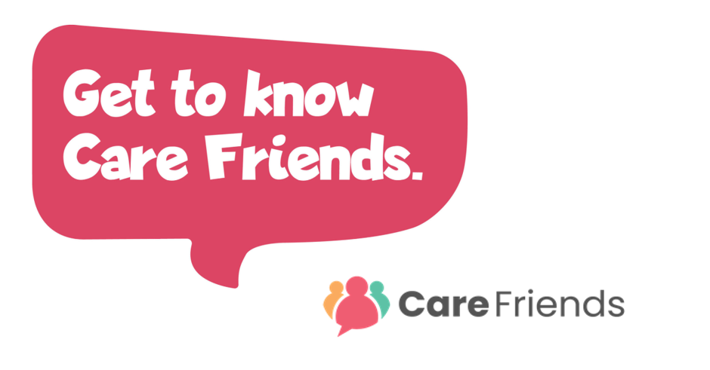
We'll shortly be launching an App to help you earn extra cash! Care Friends is a new scheme which will make referring a friend quick and easy! By sharing jobs via social media, WhatsApp and text, you’ll earn points and you can turn those points into cash! We'll be in touch soon with more information!

