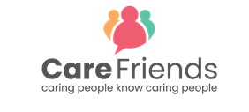
Teaser email template

How to use this resource
We’ve added a highlighted section which needs to be customised with your organisation’s details.
Once you’ve completed the highlighted section, copy the image and text into an email and send 1 week before launch
Teaser email: Send 1 week before launch

Care Friends is coming…

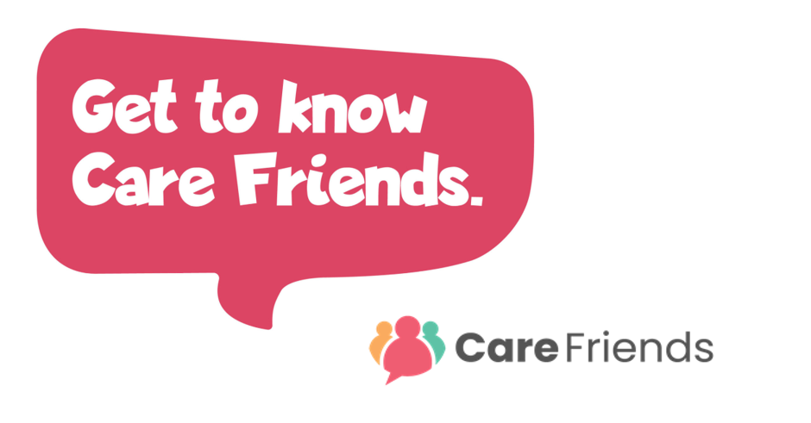

Hi everyone!

Do you know someone who would make a great addition to our team?
Well, we want to reward you for helping us find even more great people like you!

I am delighted to announce that on [insert date] we are launching Care Friends, an employee referral app especially for care staff.

By referring your friends and family, you will receive points on your app, and these points will be converted to cash!

Watch this video to find out more and look out for more info coming soon!

Get to know Care Friends

