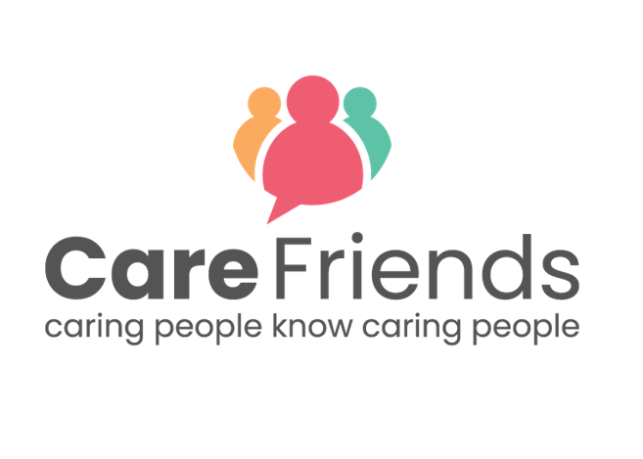
Launch Day Facebook Post
Simply complete the highlighted section of this template with your organisation details, then copy and paste the template into your Facebook post.
You can download the jpeg version of the image here
You could also download our ‘Why download the Care Friends app’ video and share it with your post to make it even more engaging!
Help us recruit and we’ll help you earn! Download the Care Friends App today and start sharing jobs on social media and with your friends and family. The app is simple to use and you can start earning points as soon as you use it and points mean extra cash!
[insert launch incentive details]
Need help registering? Contact our Care Friends Champion [insert name] who will be happy to help.
Get the app from the Apple App Store:
https://apps.apple.com/us/app/care-friends/id1464379630?ls=1
Get the app from the Google Play Store:
https://play.google.com/store/apps/details?id=uk.co.carefriends.app&hl=en_GB

