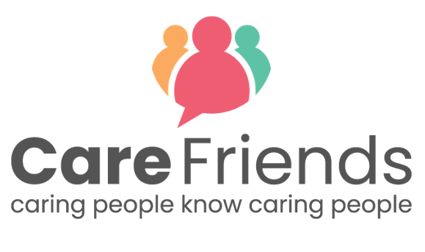

Care Friends is here!

It’s here! Care Friends is an easy-to-use app which will give you the opportunity help a friend find a job they’ll love and earn extra money in the process!

Share our jobs with your friends and family via text, Whatsapp or social media and get points which you can turn into cash - What could be better?!

[customise and insert our insert points values chart
You can find your organisation’s points values in the ‘Referral points’ tab in the ‘Settings’ section of your portal.]
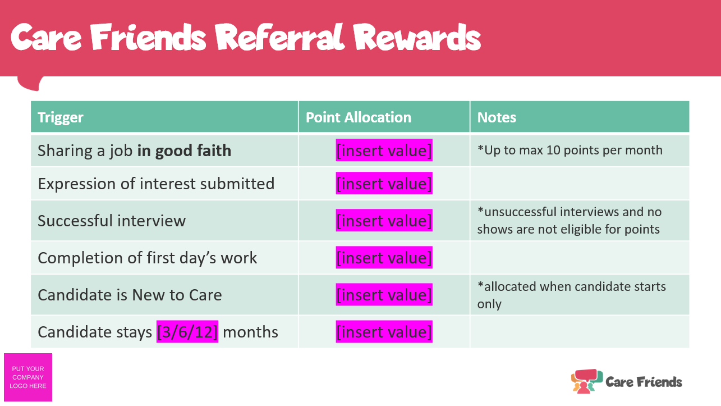

Check out this 2 minute video to find out more!

[insert launch incentive details]

Download the app today for free by clicking the link below and following the simple instructions to register. Or speak to [insert Care Friends champion name] who will be happy to help you get started.

Go to the Google play store
https://play.google.com/store/apps/details?id=uk.co.carefriends.app&hl=en_GB

Go to the apple app store
https://apps.apple.com/us/app/care-friends/id1464379630?ls=1

