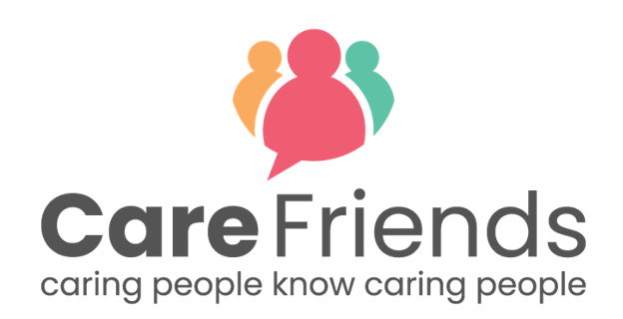

Values-based engagement campaign ideas

Idea 1 - Encourage staff to help friends find a job they will love

Copy and paste the message below and send via your usual comms method to encourage your employees to think about friends who would make a great addition to your team.

Thank you to everyone who has signed up for Care Friends.

Join the [insert number of sign ups] members of our team who have started helping their friends find a job they will love here at [insert organisation name].

We’re so lucky to have team members like you. Do you know someone who would love caring for others too?

Care Friends is an easy to use app which enables you to get rewarded for referring your friends to join our team.

Follow the link below to register or chat to our Care Friends Champion [insert champion name and contact details] who will be happy to help you get started.

Go to the Google play store
https://play.google.com/store/apps/details?id=uk.co.carefriends.app&hl=en_GB

Go to the apple app store
https://apps.apple.com/us/app/care-friends/id1464379630?ls=1

Idea 2 - Use social proof to promote Care Friends

Social proof is one of the most effective ways of promoting app usage. The more staff realise that their peers are using the app and earning points, the more likely they are to download it and use it themselves.

It would be great to get quotes from your referrers and new starters to share via your usual comms method.

You can encourage effective quotes by asking the following questions:
- For your referrer - "What's the best thing about referring a friend via the Care Friends app?"
- For your new starter - "What excited you most about being referred by a friend?"
Always include links to download and your Care Friends Champion’s contact details for those who haven’t signed up yet
Go to the Google play store
https://play.google.com/store/apps/details?id=uk.co.carefriends.app&hl=en_GB

Go to the apple app store
https://apps.apple.com/us/app/care-friends/id1464379630?ls=1

Idea 3 - Make some noise about your team’s successful referrals

Celebrating your team’s successful referrals is a fantastic way to build engagement.

[Insert referrer name with permission] from our team referred his/her friend [insert new starter name with permission] and they are joining our team!

Every time someone you refer with similar values and a great attitude like you joins our team, it enables us to help more people in our local community and provide the service level they deserve.

If you haven't signed up to Care Friends yet, do it today and help us find more great people like you!

Follow the link below to download the app for free and follow the simple instructions to register - it only takes 60 seconds to start earning rewards

If you need help registering contact our Care Friends Champion [insert champion name and contact details]
Google play store
https://play.google.com/store/apps/details?id=uk.co.carefriends.app&hl=en_GB
Apple app store
https://apps.apple.com/us/app/care-friends/id1464379630?ls=1
Idea 4 - Celebrate your organisation’s success with quick and easy message templates

Template 1: Number of referrals

So far our team has referred [insert number of starters] via the Care Friends app - that's AMAZING! To sign up and start referring you friends and earning extra cash too, click on the link below and follow the simple instructions to register.

Need help with registering? Contact our Care Friends Champion [insert name and contact details] who will be happy to help!
Google play store
https://play.google.com/store/apps/details?id=uk.co.carefriends.app&hl=en_GB
Apple app store
https://apps.apple.com/us/app/care-friends/id1464379630?ls=1

Template 2: Number of new starters
Every time you refer someone to work with us you earn rewards! And in just [insert value] months, thanks to all of you, we've got [insert value] new employees. If you haven't signed up to the Care Friends app yet, do it today and start earning cash rewards too!

Chat to our Care Friends Champion [insert name and contact details] who will be happy to help you get started!

Google play store https://play.google.com/store/apps/details?id=uk.co.carefriends.app&hl=en_GB
Apple app store
https://apps.apple.com/us/app/care-friends/id1464379630?ls=1

