Teaser Facebook Post
Simply copy and paste the template into your Facebook post 7 days prior to launch.
You can download the jpeg version of the image to go with the post here
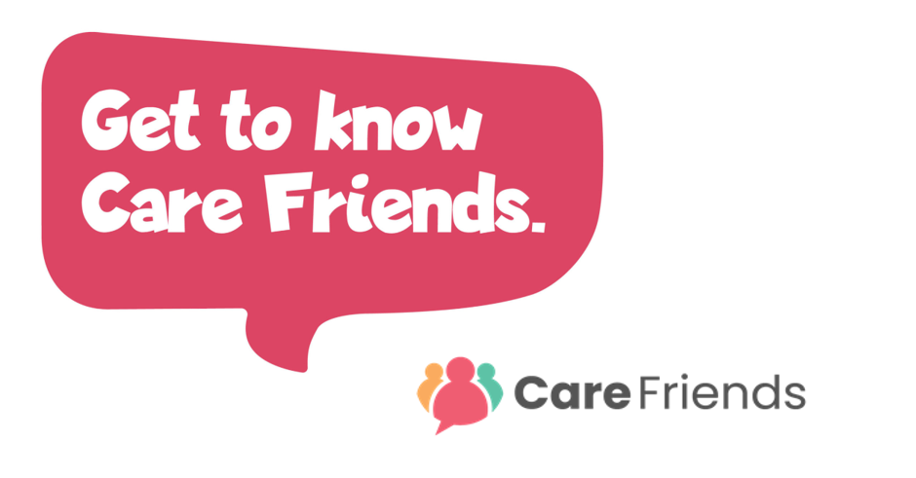
We'll shortly be launching an App to help you earn extra cash! Care Friends is a new scheme which will make referring a friend quick and easy! By sharing jobs via social media, WhatsApp and text, you’ll earn points and you can turn those points into cash! We'll be in touch soon with more information!

Launch Day Facebook Post
Simply complete the highlighted section of this template with your organisation details, then copy and paste the template into your Facebook post.
You can download the jpeg version of the image here
You could also download our ‘Why download the Care Friends app’ video and share it with your post to make it even more engaging!
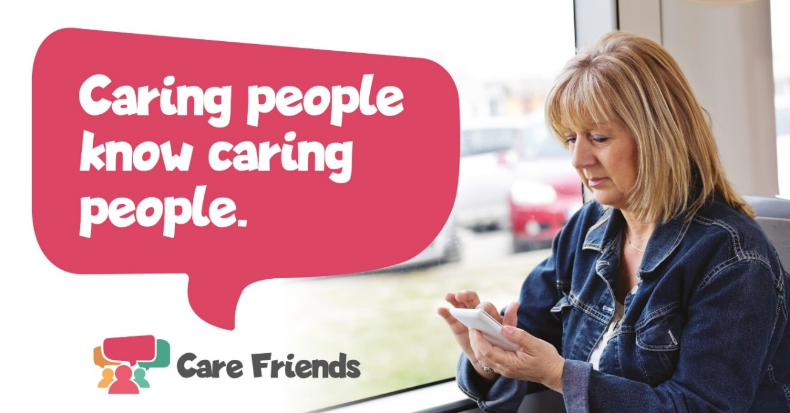
Help us recruit and we’ll help you earn! Download the Care Friends App today and start sharing jobs on social media and with your friends and family. The app is simple to use and you can start earning points as soon as you use it and points mean extra cash!
[insert launch incentive details]
Need help registering? Contact our Care Friends Champion [insert name] who will be happy to help.
Get the app from the Apple App Store:
https://apps.apple.com/us/app/care-friends/id1464379630?ls=1
Get the app from the Google Play Store:
https://play.google.com/store/apps/details?id=uk.co.carefriends.app&hl=en_GB

Post-Launch Team Facebook Posts
Use this series of Facebook posts to keep up momentum following launch day. Follow the link below to download the jpeg image files that accompany these posts.
Download the jpeg image files here
Simply complete the small highlighted sections of each template with your organisation details, then copy and paste the template into your Facebook post.

Facebook Post 3 – post 2 days after launch day
How many friends do you have on Facebook? Plenty, for sure! Download the Care Friends App and start sharing jobs on Facebook. As soon as you do, you can start earning points which you can then turn into cash!
Need help registering? Contact our Care Friends Champion [insert name] who will be happy to help.
Get the app from the Apple App Store:
https://apps.apple.com/us/app/care-friends/id1464379630?ls=1
Get the app from the Google Play Store:
https://play.google.com/store/apps/details?id=uk.co.carefriends.app&hl=en_GB

Facebook Post 4 – post 4 days after launch day

Love to care? Tell your world! Care Friends is a new App that will help you refer friends to work alongside you. Share a post on Facebook, WhatsApp or via SMS and earn points which you can turn into cash. It's simple to use and easy to register. Just visit your App store, search for Care Friends and you'll be guided through the rest.
Need help registering? Contact our Care Friends Champion [insert name] who will be happy to help.
Get the app from the Apple App Store:
https://apps.apple.com/us/app/care-friends/id1464379630?ls=1
Get the app from the Google Play Store:
https://play.google.com/store/apps/details?id=uk.co.carefriends.app&hl=en_GB

