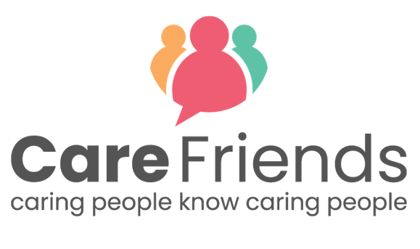
Post-Launch Email Templates

Use this series of emails to keep up momentum following launch day.
Simply complete the highlighted sections of each template with your organisation details, then copy and paste the template into your emails.

Send 2 days after launch
Join the Care Friends app today!

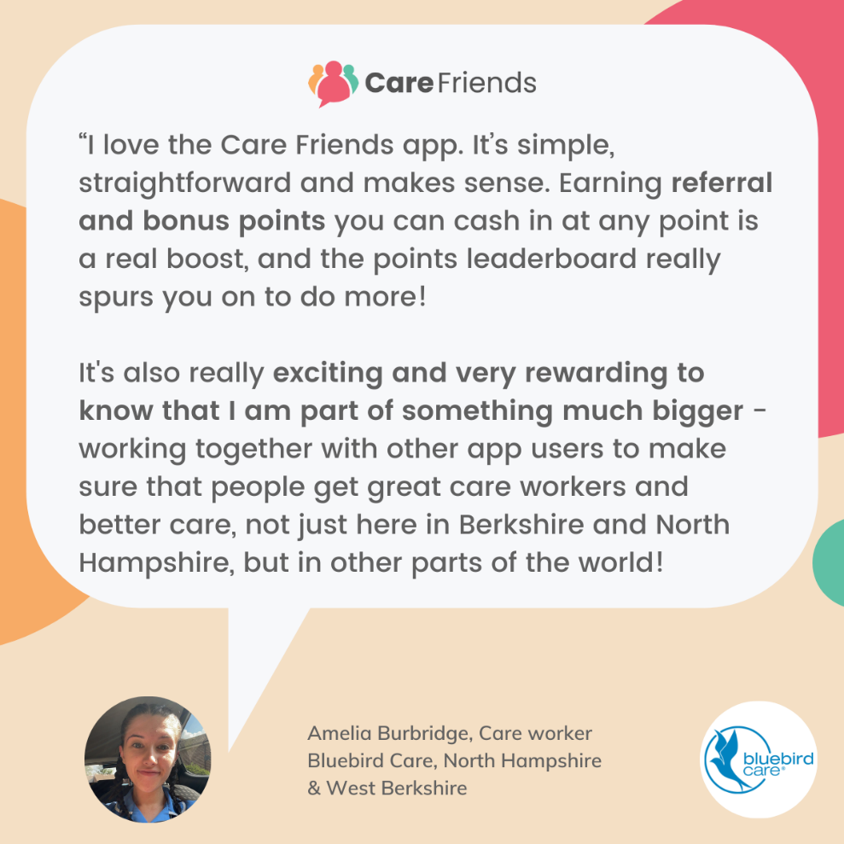

Thank you to everyone who has downloaded the Care friends app!

Join the [insert number of sign ups] members of our team who have shared a job via text, whatsapp or social media and started earning points!

Remember points = extra cash in your pocket!

Check out this 2 minute video to find out more!

Download the app for free today by clicking the link below and follow the instructions to register. Or speak to [insert Care Friends champion name] who will be happy to help you get started.

Go to the Google play store
https://play.google.com/store/apps/details?id=uk.co.carefriends.app&hl=en_GB
Go to the apple app store
https://apps.apple.com/us/app/care-friends/id1464379630?ls=1

[insert launch incentive reminder]

Send 4 days after launch

Earn extra cash with the Care Friends app!

[insert points values chart - find a template for this here you can find your organisation’s points values in the ‘Referral points’ tab in the ‘Settings’ section of your portal.]
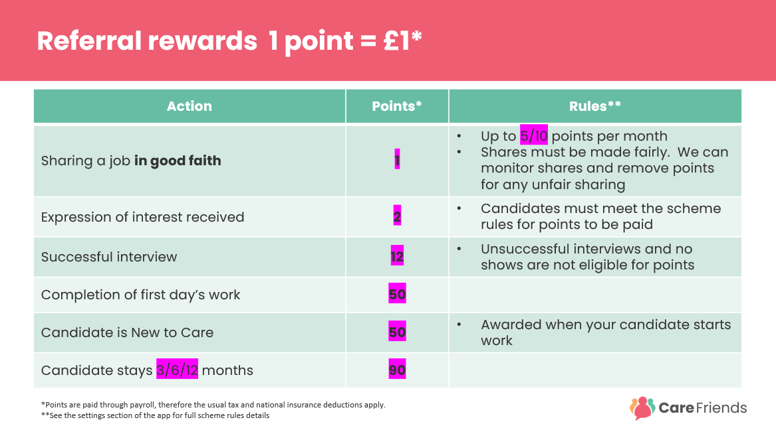

Thanks to everyone who has downloaded the Care Friends app so far!

When you refer a friend using the Care Friends app you receive rewards for each step of the hiring process, not just hires!

Visit the app now to see how many points you have and share the jobs we have available with your friends and family.

Not signed up yet? Check out this 2 minute video to find out more and download the app for free by clicking the link below and follow the instructions to register. Or speak to [insert Care Friends champion name] who will be happy to help you get started.

Go to the Google play store
https://play.google.com/store/apps/details?id=uk.co.carefriends.app&hl=en_GB

Go to the apple app store
https://apps.apple.com/us/app/care-friends/id1464379630?ls=1

[insert launch incentive reminder]
Send 7 days after launch

Care Friends Week 1

Hi everyone,

Thank you for your support for Care friends!

In just one week, thanks to all of you, we’ve had [insert expressions of interest + other highlights] - that’s amazing!

If you haven't signed up to the Care Friends app yet, do it today and start earning extra cash for referring you friends too!

[insert launch incentive reminder]

Here’s a quick video to show you how easy it is to get started…

https://vimeo.com/675444421
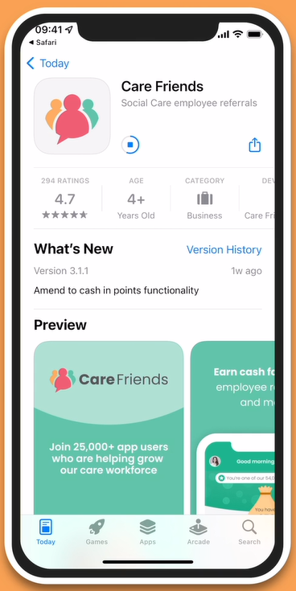

Speak to [insert Care Friends champion name] if you need any help to register.

Send 9 days after launch

[Insert welcome bonus/prize draw as the title]

Hi everyone!

Remember to download the Care Friends app to [insert launch incentive details]

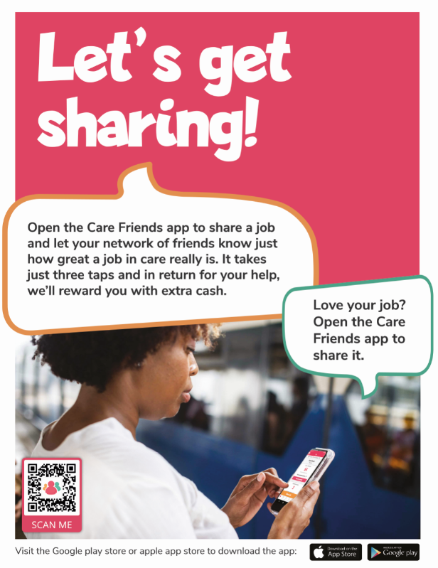

Our [insert launch incentive details] finishes on [insert sign up incentive deadline], so don’t delay! Head to the Google play store or the apple app store now and download the app for free!

Go to the Google play store
https://play.google.com/store/apps/details?id=uk.co.carefriends.app&hl=en_GB

Go to the apple app store
https://apps.apple.com/us/app/care-friends/id1464379630?ls=1

If you need any support getting started, speak to [insert Care Friends champion name] who will be happy to help.

