**Remember to include your launch incentive details!**

**Add emojis to your messages to make them personal and fun!**

**We’ve created a series of messages that can be sent to your existing staff at various stages using SMS or Whatsapp.**

**Teaser Whatsapp & SMS messages – Send 7 days before launch**

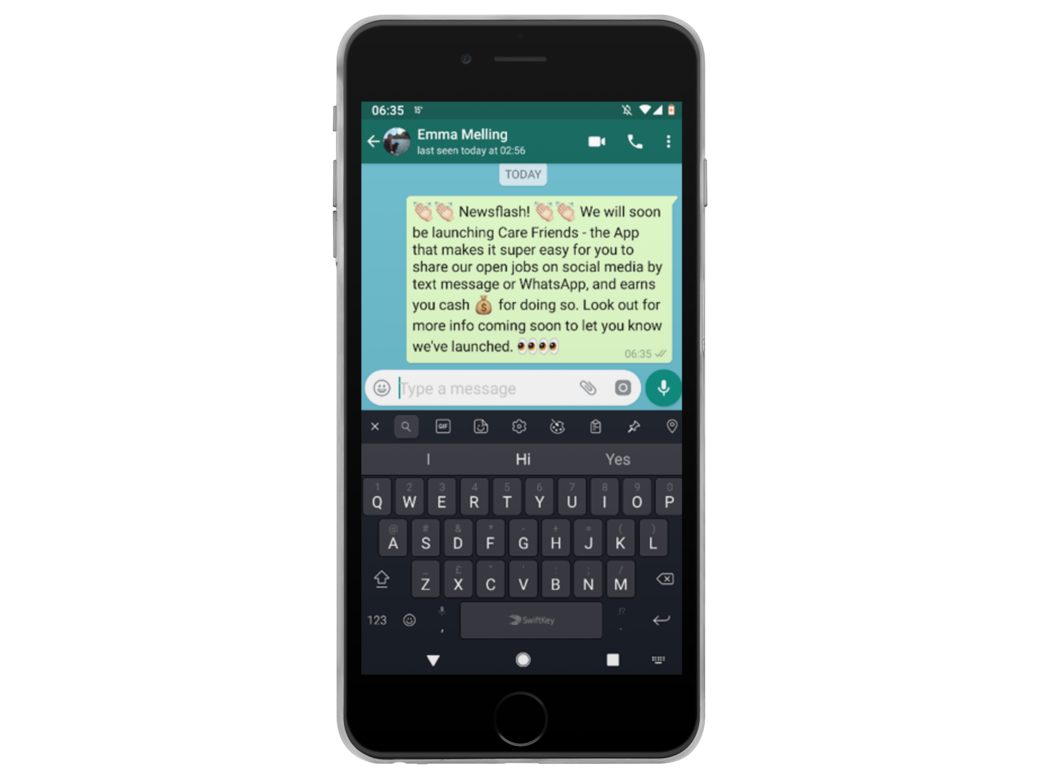

**SMS/WhatsApp One – send this a week before launch to let your team know that Care Friends is coming!**

**Newsflash! We will soon be launching Care Friends – the App that makes it super easy for you to earn extra cash for sharing our open jobs on social media, by text message or WhatsApp. Look out for more info coming soon!**

**Use emojis to make the message as personal and fun as possible!**

**Launch day Whatsapp & SMS messages- Send on launch day**

**WhatsApp Two – this message tells employees that the App is now available for them to download and should be the second one you send.**

**It’s here! We are launching Care Friends, an easy to use app that gives you the opportunity to earn points that turn into cash!**

**Share our jobs on social media with your friends and family and start earning points today!**

**Download the app for free by clicking the link below and following the simple instructions to register.**

**Google Play store link:** [**https://play.google.com/store/apps/details?id=uk.co.carefriends.app**](https://play.google.com/store/apps/details?id=uk.co.carefriends.app)

**Apple App Store link:** [**https://apps.apple.com/us/app/care-friends/id1464379630?ls=1**](https://apps.apple.com/us/app/care-friends/id1464379630?ls=1)

**Post launch day Whatsapp & SMS messages – Send any time following launch**

**

**Love your job? Tell your friends! Care Friends is an easy-to-use app which gives you the opportunity to earn points for referring your friends to join our team.**

**And what do points mean? Extra cash in your pocket!**

**Download the app today by clicking the link below to get started.**

**Google Play store link:** [**https://play.google.com/store/apps/details?id=uk.co.carefriends.app**](https://play.google.com/store/apps/details?id=uk.co.carefriends.app)

**Apple App Store link:** [**https://apps.apple.com/us/app/care-friends/id1464379630?ls=1**](https://apps.apple.com/us/app/care-friends/id1464379630?ls=1)

**WhatsApp Three – the first message which explains more about the App and where to go to download it.**

**WhatsApp Four – a reminder to download the app and why they should.**

**Love to care? Tell your world!  
Remember to download our new Care Friends app to start earning rewards for telling your network about our available jobs!**

**The app is free, it takes just 60 seconds to register and you can start earning rewards straight away!**

**Google Play store link:** [**https://play.google.com/store/apps/details?id=uk.co.carefriends.app**](https://play.google.com/store/apps/details?id=uk.co.carefriends.app)

**Apple App Store link:** [**https://apps.apple.com/us/app/care-friends/id1464379630?ls=1**](https://apps.apple.com/us/app/care-friends/id1464379630?ls=1)

**WhatsApp Five – a reminder to check into the app and share jobs, check their points total or cash in their points.**

**Thanks for downloading the Care Friends app. Visit the app now to see how many points you have and trade them in for cash. Remember it’s super easy to share a job with someone who you think would make a great addition to our team.**

**If you’re not registered yet, download the app today!**

**Google Play store link:** [**https://play.google.com/store/apps/details?id=uk.co.carefriends.app**](https://play.google.com/store/apps/details?id=uk.co.carefriends.app)

**Apple App Store link:** [**https://apps.apple.com/us/app/care-friends/id1464379630?ls=1**](https://apps.apple.com/us/app/care-friends/id1464379630?ls=1)

